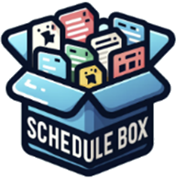
https://www.schedulesbox.com/
NOTES
REMINDER
☐
☐
☐
☐
☐
☐

TIME | APPOINTMENT / CLIENT | PHONE
07:00 AM | Treatment Type | +555 222 123
07:30 AM | Treatment Type | +555 222 123
08:00 AM | Treatment Type | +555 222 123
08:30 AM | Treatment Type | +555 222 123
09:00 AM | Treatment Type | +555 222 123
09:30 AM | Treatment Type | +555 222 123
10:00 AM | Treatment Type | +555 222 123
10:30 AM | Treatment Type | +555 222 123
11:00 AM | Treatment Type | +555 222 123
11:30 AM | Treatment Type | +555 222 123
12:00 PM | Treatment Type | +555 222 123
12:30 PM | Treatment Type | +555 222 123
01:00 PM | Treatment Type | +555 222 123
01:30 PM | Treatment Type | +555 222 123

Salon Appointment Schedule
Instructor:

Date:

